ANDROID BASED CLEARANCE SYSTEM FOR BINDURA UNIVERSITY OF SCIENCE EDUCATION (BUSE) GRADUANDS



CHIKURUWO WENSELOUS (R178513Y)
ANDROID BASED CLEARANCE SYSTEM FOR BINDURA UNIVERSITY OF SCIENCE EDUCATION (BUSE) GRADUANDS

By
CHIKURUWO WENSELOUS (R178513Y)

Submitted in partial fulfilment of the requirements for the degree of

BSc Honours Information Systems

Department of Computer Science and Information Systems
in the
Faculty of Science and Technology
at the
Midlands State University
Gweru
June 2019

Supervisor: MRS MUTEMBEDZA

LIST OF ACRONYMS
App - Application
BUCSE - Bindura University College of Science Education
BUSE – Bindura University of Science Education
HTML - Hypertext Markup Language
MYSQL - My Structured Query Language
PHP – Hypertext Pre-processor

Table of Contents
LIST OF ACRONYMS ii
Table of Contents iii
CHAPTER ONE: INTRODUCTION 1
1.1 INTRODUCTION 1
1.2 BACKGROUND OF THE STUDY 1
1.2.1 BACKGROUND OF THE ORGANISATION 2
1.2.2 ORGANISATIONAL STRUCTURE 4
1.2.3 VISION 5
1.2.4 MISSION STATEMENT 5
1.3 PROBLEM DEFINITION 5
1.4 AIM 6
1.5 OBJECTIVES 6
1.6 INSTRUMENTS AND METHODS 6
1.7 JUSTIFICATION AND RATIONALE 6
1.8 CONCLUSION 7

CHAPTER ONE: INTRODUCTION

1.1 INTRODUCTION
The purpose of this research is to come up with an Android Based Clearance system for Bindura University of Science Education graduands in order to solve some of the challenges they face upon completion of their studies. The system seeks to reduce the burden a student faces during the whole clearance process. A student gets a clearance form from the faculty which has to be signed first by the Chairman, goes to the next department which is the Bursary according to form, then visits the Library for clearance which is located in town. The next department is the Student Affairs then the Registry and finally to Examinations office for the final processing of transcript and collection of a certificate. With this proposed system, students will be able to apply for clearance in the comfort of their homes. Hence, this will eliminate the manual system which is very much tiresome to these outgoing students. This chapter also focuses on quite a number of areas which include the background to the study, the statement of the problem, aim, objectives, instruments and justification of the study as well as the summary.

1.2 BACKGROUND OF THE STUDY

At Bindura University, clearing of graduating students has consistently been a manual process. Several attempts were made by the University to replace the existing manual process with an online clearance system for the outgoing students but to this day clearance is still a manual process. The University operates using multi-faculty system and presently has five faculties; Commerce, Science and Engineering, Science Education, Social Sciences and Humanities and Agriculture and Environmental Sciences. All these faculties are in different locations and several kilometers apart, there is need for an automated method of keeping data, more so there is a greater need for an online Android-Based clearance system. Hence, this will go a long way in alleviating the various problems and challenges involved in the manual method of clearance. This idea of developing an android clearance system will curtail the existing manual system which is tedious and time consuming.

1.2.1 BACKGROUND OF THE ORGANISATION

According to a BUSE Prospectus (2012-2013), the Bindura University College of Science Education (BUCSE) was established in 1995 as a way of trying to address the shortage of Science Teachers. Prior to this arrangement, training was being done in Cuba on a government to government arrangement. The University is temporarily operating from the Bindura Provincial Public Service Training Centre.
The College opened its doors on March 1996 with a small intake of 125 students. This led to the termination of Zimbabwe – Cuba Science Teacher programme which according to the BUSE prospectus (2012 – 2013) had began in the mid of 1980s. Five lecturers from Cuba were among the staff that was first recruited to be part of this historical initiation.
Bindura University of Science Education Act (2000), The Bindura University of Science Education Act was gazetted by the government in February 2000, hence conferring it to University status from being a College. That was the birth of BUSE, the C which was at the middle of the acronym BUCSE was droped. According to BUSE website (2019), to date the University has been headed by three Vice Chancellors. At present the Vice Chancellor is Professor Eddie Mwenje. According to the BUSE website (2019), construction of the Main Campus is under way at the moment on a 159 hectare plot about two kilometres from the town centre along the Bindura - Mount Darwin Road. According to the Registry records, the student enrolment is now 5300.

1.2.2 ORGANISATIONAL STRUCTURE
Armstrong (2009) defined a structure as “a typically hierarchical arrangement of lines of authority, communications, rights and duties of an organization”. Armstrong (2009) further explained that “this structure covers how activities are grouped together, the number of levels in the hierarchy, the extent to which the authority is decentralized to divisions”. Hence, basically it determines how information flows between levels within an organization. Below is BUSE organogram.
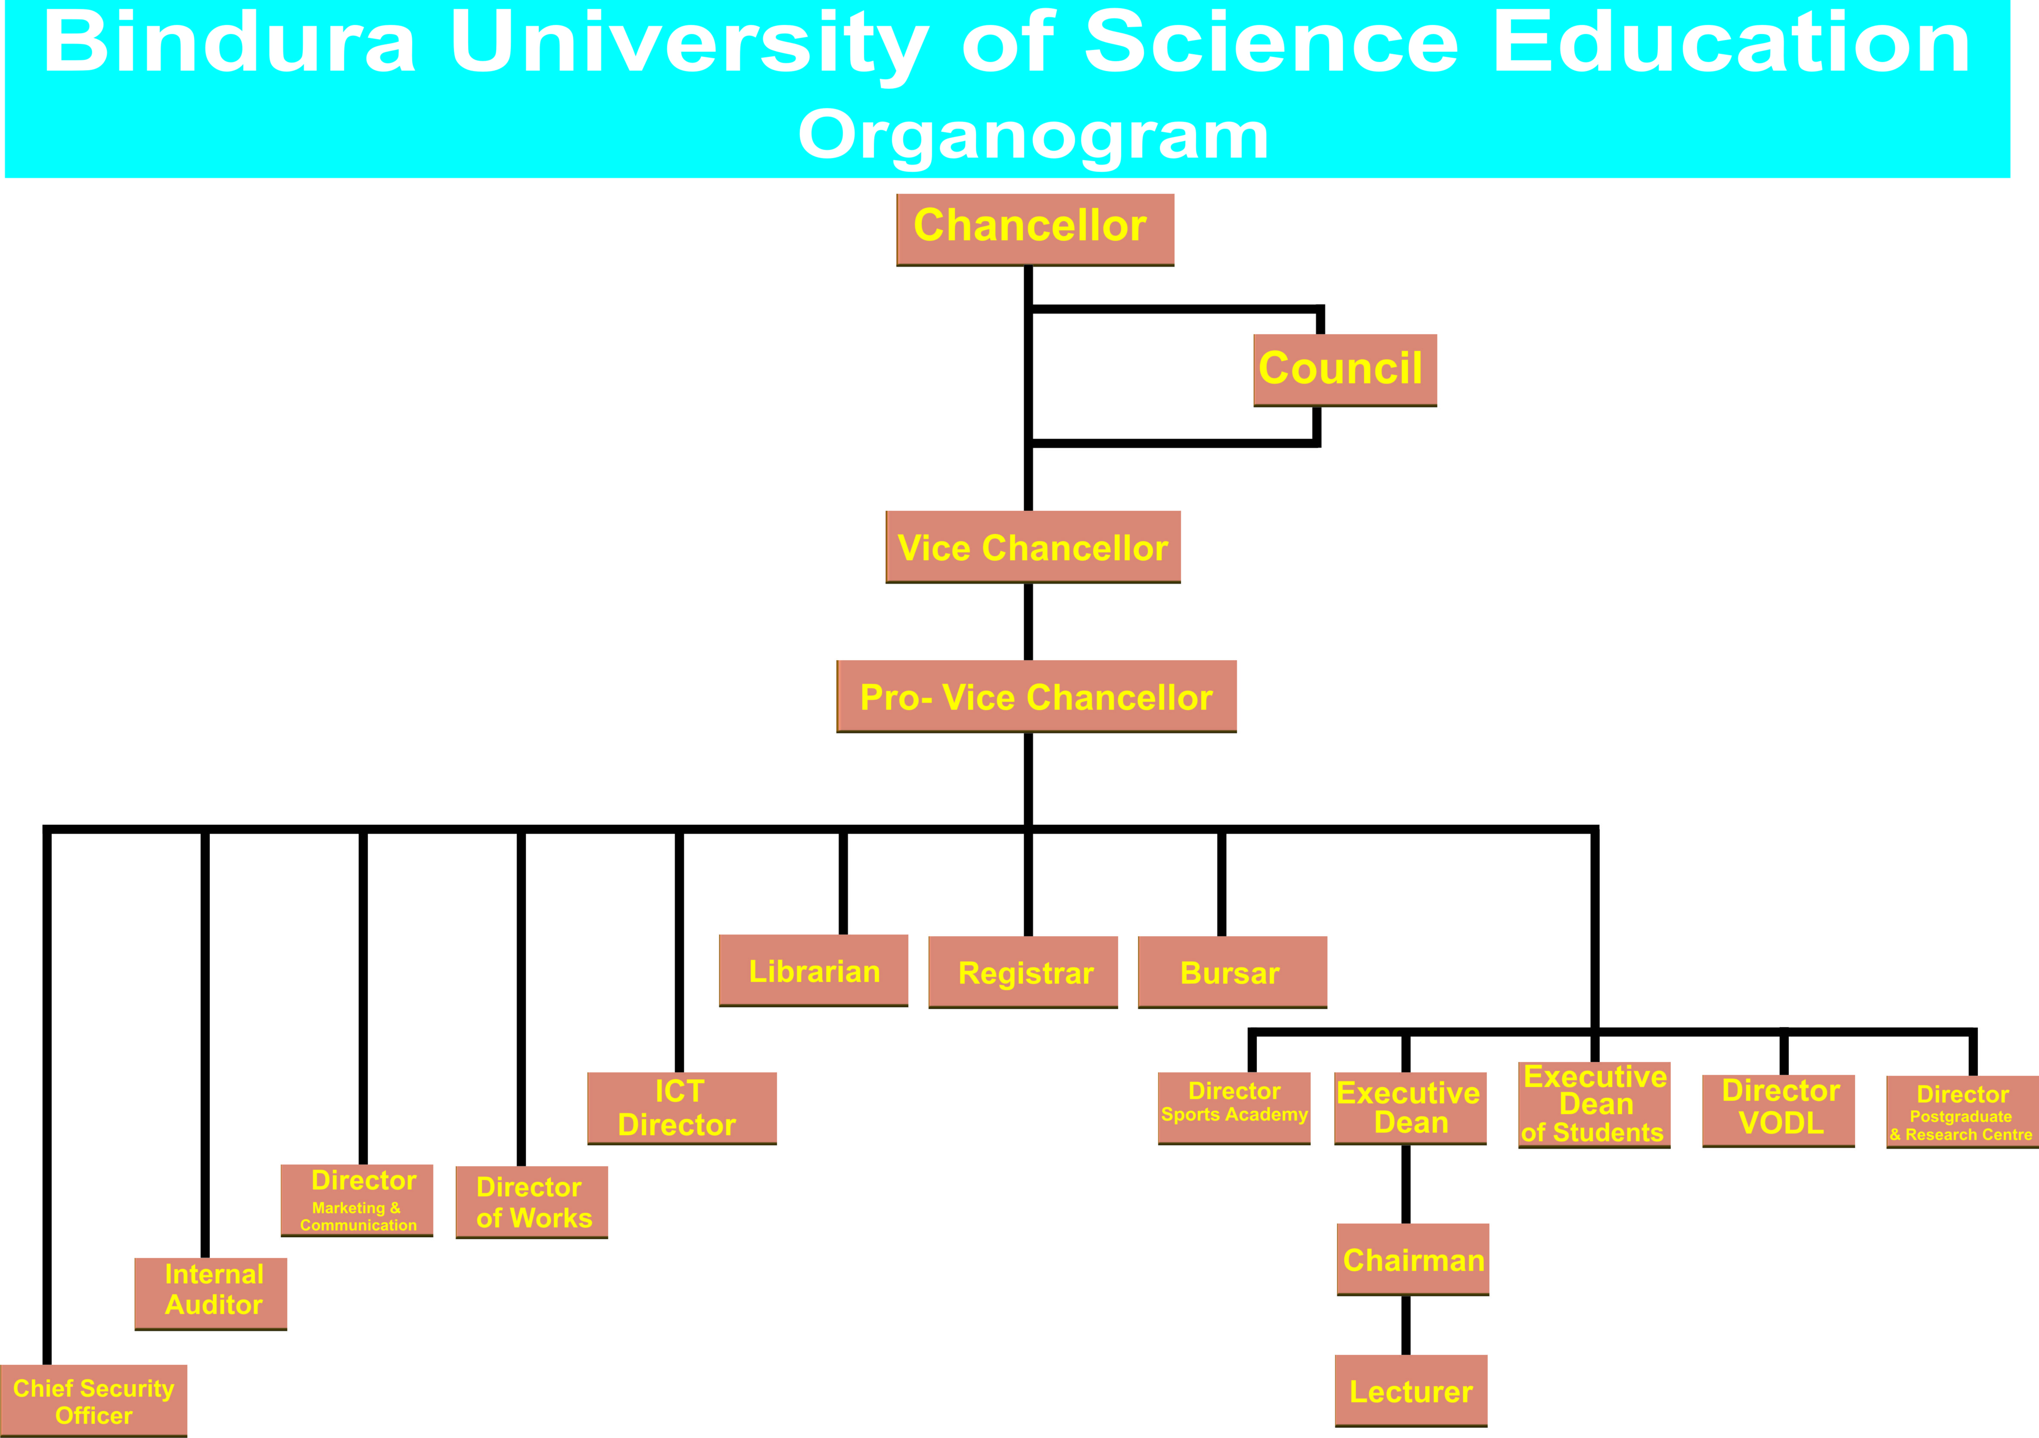

1.2.3 VISION
Mathis(2001) defined vision as the core reason for the existence of the organization and what makes it unique. The vision of BUSE reads, “Bindura University of Science Education seeks to be a hub of knowledge and beacon of excellence in teaching, research and extension services”.

1.2.4 MISSION STATEMENT
Field(1998) defined a mission as a brief description of what the group (which could be the entire organization or some part of it) believes it has been organized to do. BUSE mission statement reads, “To contribute to the advancement of knowledge and its practical application to social economical cultural and scientific challenges; to produce innovative, highly acclaimed graduates equipped with research, entrepreneurial, social and technical skills for the benefit of the nation and the international community”.
1.3 PROBLEM DEFINITION
A problem definition was defined as “a brief explanation of the problem under investigation.”(Chiromo (2006:p84). He further pointed out that the problem should be clearly and explicitly stated and of significance otherwise there will be no need to work on it. Therefore, at BUSE the process of clearing students after completion of their academic studies requires one to be cleared in various departments which include:
Academic Department
Bursary Department
Library Department
Students affairs Department
Registry
Examinations office for the final processing of transcript and collection of a certificate
For a graduand to carry out the clearance exercise from all these departments, it normally takes a day or two days and a lot of procedures and delays in clearing the graduand up to the collection of transcript. Sometimes students hire taxes to be ferried from one campus to the other. At times delays might occur as a result of internet connectivity between the campuses or the unavailability of electricity. In such a scenario, the graduand will be forced to wait until network or power has been restored. The set-up is bad considering the distances between campuses – the furthest campus being about 8km away. Sometimes students are being caught unaware when they will be informed about the outstanding material or fine in their account in which they have to settle first before being cleared. Lots of complaints have been raised about the unavailability of the Chairperson of a department in office, thereby resulting in the student to wait sometimes more than necessary. A lot of graduands could echo sentiments like not to recommend any potential student to get enrolled with BUSE because of the frustration that will go up to the last day of the clearance process. It is in light of this background that the development of an online android-based clearance system that will do away with the limitation of the manual system is warranted.

1.4 AIM
According to Solent website (2019) an aim is a statement of intent. Thus what one is hoping to achieve at the end of the project. Therefore the aim of this project is to develop an Android-Based Clearance system for Bindura University of Science Education Graduands.

1.5 OBJECTIVES
Field (1998) described objectives as what the organization or an individual wants to achieve. Therefore the objectives of this project are:
To develop an android-based clearance system that is real time, which enable the student to access the details from the institution through the integration of all University clearance system databases.
To optimize system efficiency by implementing queuing and scheduling of tasks using the FIFO scheduling method.
To notify the applicant about the clearance status through push notifications

1.6 INSTRUMENTS AND METHODS
Kumar (2014) defined instruments as “tools which are used to accomplish a certain task and methods are the techniques used to collect relevant information from a specific group of stakeholders needed for understanding the operations of a certain activity as well as their expectations from that activity”. Chiromo (2006) found out that there is also need to describe and justify the research design and procedures that will be followed in collecting data therefore procedures and techniques will be followed in developing this system.
1.6.1 INSTRUMENTS
Instruments that will be used to develop this application include Android Studio, or Flutter softwares, PHP (Hypertext Preprocessor), and XAMPP which has got MySQL for the database. Microsoft office will be used for documentation. Other devices to be used will be an HP laptop with a Windows 10 operating system installed on it and an Android phone.

1.6.2 DATA COLLECTION PROCEDURES

(i) Observations
Observations are one of the data collection tools to be used. According to Chiromo (2006), “observations seeks to ascertain what people think and do by watching them in action as they express themselves in various situations and activities”. Hence, they give accurate information on matters of most interest, in this case how students run around all the campuses to be cleared with various departments.

(ii) Questionnaires
According to an online site Tutorials Point (2014), a questionnaire was defined as “a document with pre-defined set of objective questions and respective options is handed over to all stakeholders to answer, which are collected and compiled”. Questionnaires are going to be distributed to graduands who will be clearing, members of staff from various departments that are directly involved in the clearance process of the graduands.

(iii) Interviews
This refers to the interaction between the person who is collecting data and the people he/she is collecting data from Chiromo (2006), highlighted that interviews are helpful for getting the tale behind a participant’s experiences. Therefore in view of this, interviews will be carried out to the graduands as well as to staff who are directly involved with the clearance process.

1.7 JUSTIFICATION AND RATIONALE
The proposed system will ease the queuing system currently used at the University as the android-based clearance system will help the graduands to speed up the process of clearing in various departments instead of moving around to various campuses and offices for clearance. Some of the advantages this system will also offer will be:
To save time thereby alleviating things like psychological stress to the graduands and that of the people involved in the clearance process.
The proposed system will conveniently enable to apply for clearance forms online since most people notably students’ use android smart phones.
Information processing will be faster than before and delays can be of minimum.
It will be less costly to students and the University management at large.
It will also help in reducing costs such as labor and stationery

1.8 CONCLUSION
The system is going to be developed based on the explanation of the problem that has been highlighted and the laid down objectives. Since the world we are living in has become dynamic and more technical, the development of such a system is of great significance to students and the University at large. In the following chapter, attention shall be paid to the planning phase, which according to Field (1998) is the second phase in the project life cycle.
REFERENCE
Armstrong M.(2009) Armstrong’s Handbook of human resource management practice; 11th ed. London: Kogan Page.
Bindura University of Science Education (2012-2013). Bindura University Prospectus. Bindura: Bindura Press.
Chiromo Alois (2006) Research methods and statistics in education: a student’s guide. Gweru: Midlands State University.
Field, Mike and Laurie Keller (1998) Project Management. Hampshire: South-Western.
Kumar Dipak (2003) Research Methodology. New Dehli: Excel Books.
Mathis, Robert and Jackson, John (1997) Human Resource Management. Minneapolis/St Paul: West.
Bindura University of Science Education website https://www.buse.ac.zw/about-us/background-history/ [Accessed on 15 March 2019].
Tutorials Point webpage https://www.tutorialspoint.com/software_engineering/software_engineering_tutorial.pdf [Accessed on 27 March 2019].
Solent Online Learning website https://learn.solent.ac.uk/mod/book/view.php?id=116233&chapterid=15294 [Accessed on 27 March 2019]

